Software Engineering

Digital Assignment-2

# Done By: S Vishwajith 23BCE1145

# Project Title: Lost And Found Item Tracker

## Architectural Prototype (screen shots):

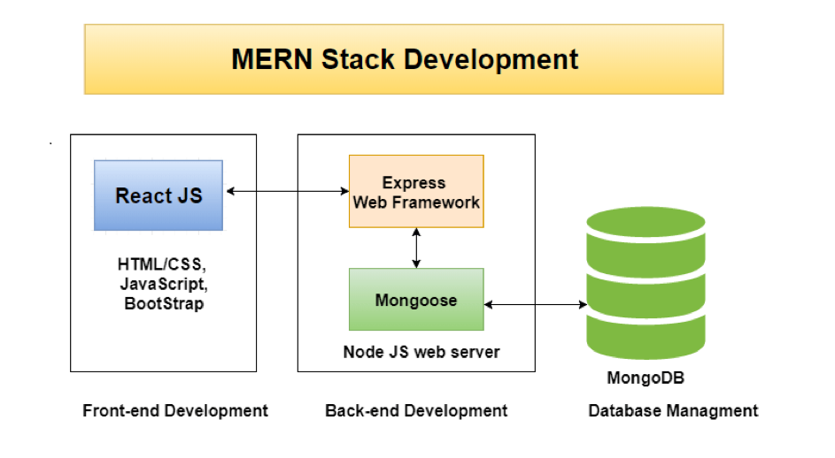

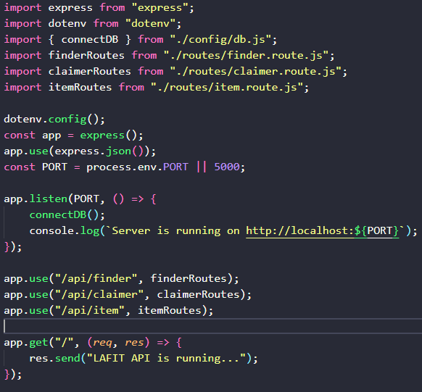

## User interface prototype (screen shots):

## Screen shots of developed functionalities:

* 1. Light/Dark Mode toggle:

* 1. Creation of Finders, Claimers, and Items:

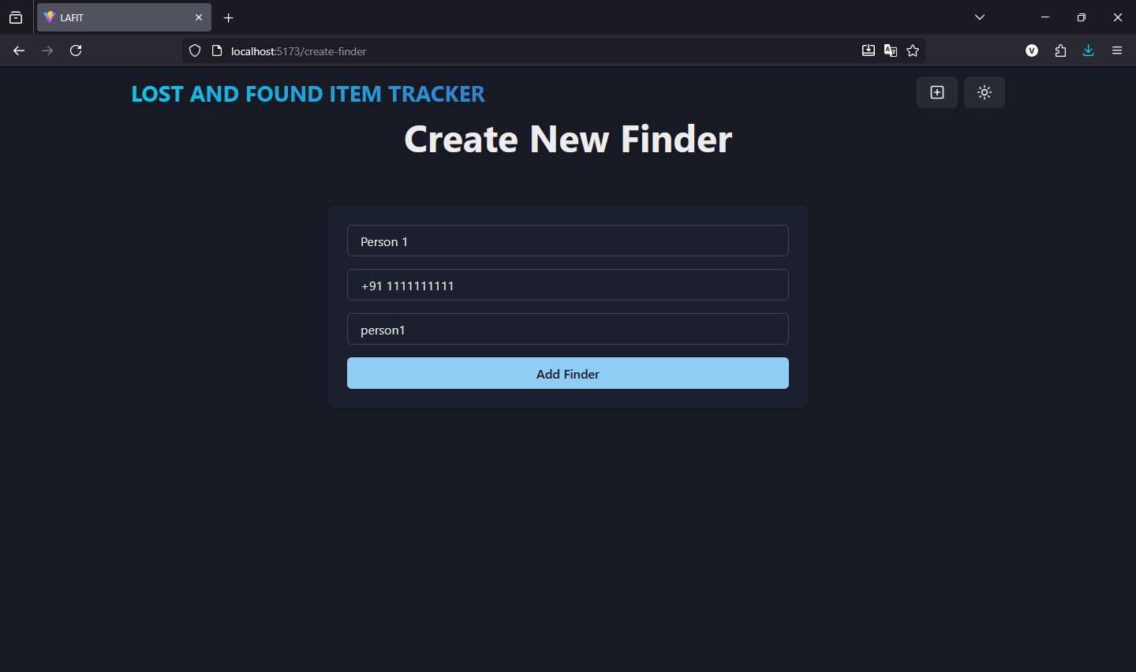

* 1. Editing of Finder, Claimer, and Item details:

## Tools/Technologies used:

* **MongoDB:** A NoSQL database which is used to store data of claimers, finders, and items.
* **ExpressJS:** A JavaScript framework built on top of Node.JS to simplify networking (example, routing).
* **Node.JS:** A JavaScript framework that allows JavaScript code to run without a browser or otherwise used to build the backend.
* **ReactJS:** A JavaScript framework used to build the frontend with UI/UX elements with trackable states.
* **VSCode:** An IDE developed using Electron to edit code belonging to various languages with support for extensions for scalability.

## SOLID principles application (Screenshots):

* 1. **Single Responsibility Principle:** Distinction of finders, claimers, and items.

* 1. **Open/Closed Principle:** The Schema of finders, claimers and items remain constant, but the APIs can be modified.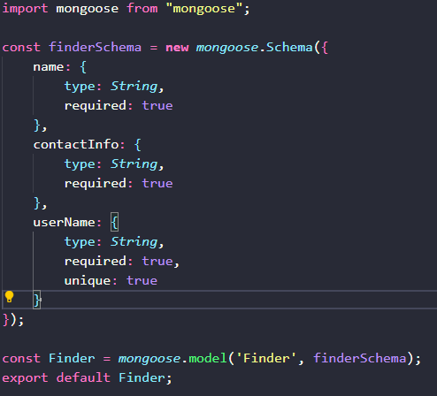

* 1. **Liskov’s Substitution Principle:** Since we don’t need to use classes here, we do not need to be concerned about inheritance, child-parent classes, etc.
  2. **Interface Segregation Principle:** The distinction between the view/delete pages, create pages, and edit pages have been clearly defined between finders, claimers and items.

* 1. **Dependency Inversion Principle:** This is impossible to implement in a language like JavaScript, as it is prototype based rather than being class based like Java.